Football Club Management System - Admin Guide

1. Admin Login
- Navigate to the login button
- Enter email + password (admin credentials)
- Redirected to Admin Dashboard with access to management modules
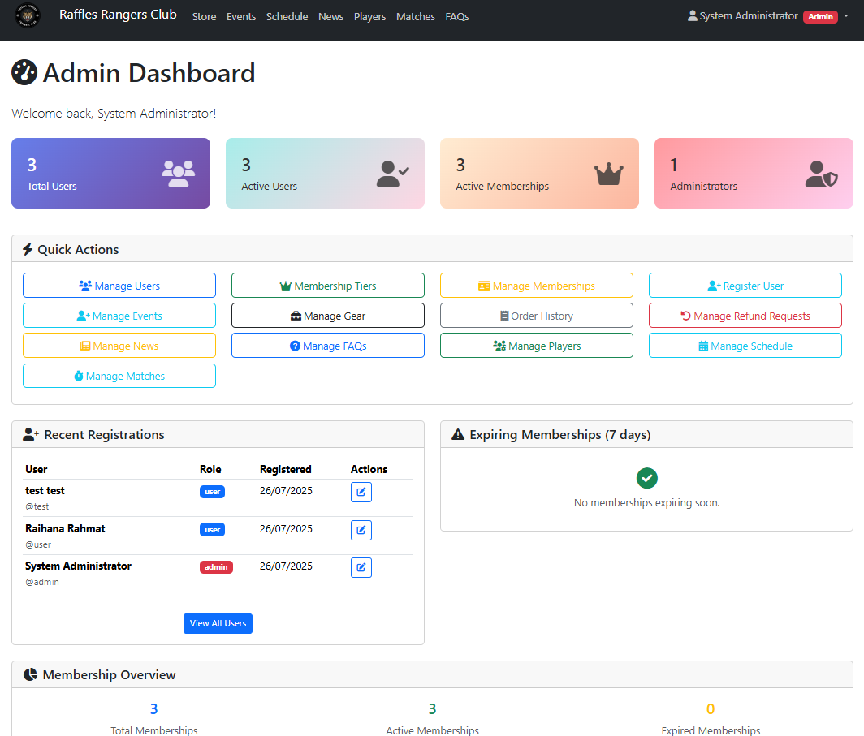

2. Manage Users

View/Edit/Delete Users
- Click “Manage Users”
- View all registered users (with profile info)
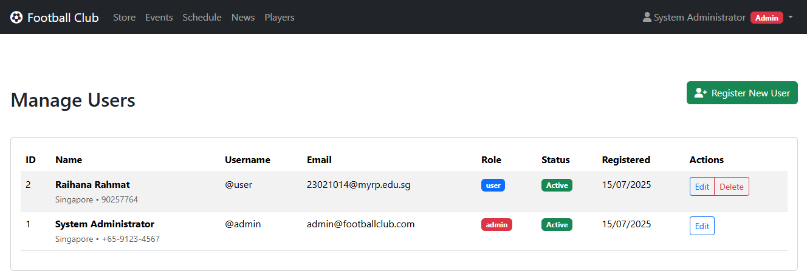
- Click “Edit” to update profiles (name, email, etc.)
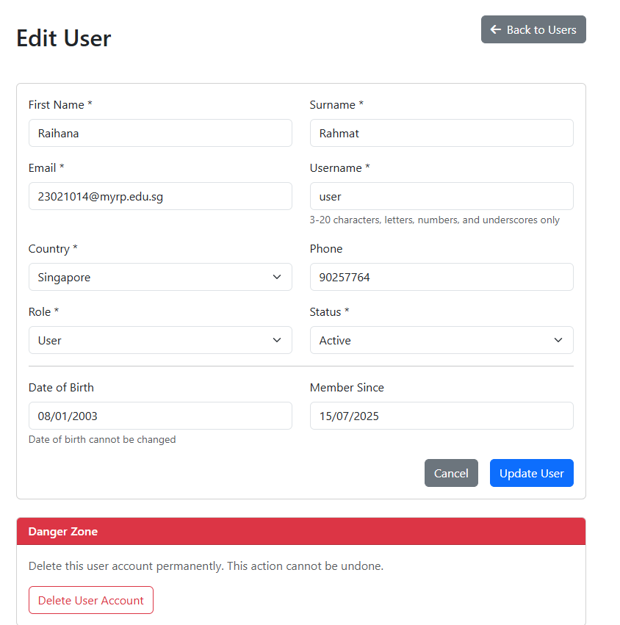
- Click “Delete” to remove users (confirmation prompt included)
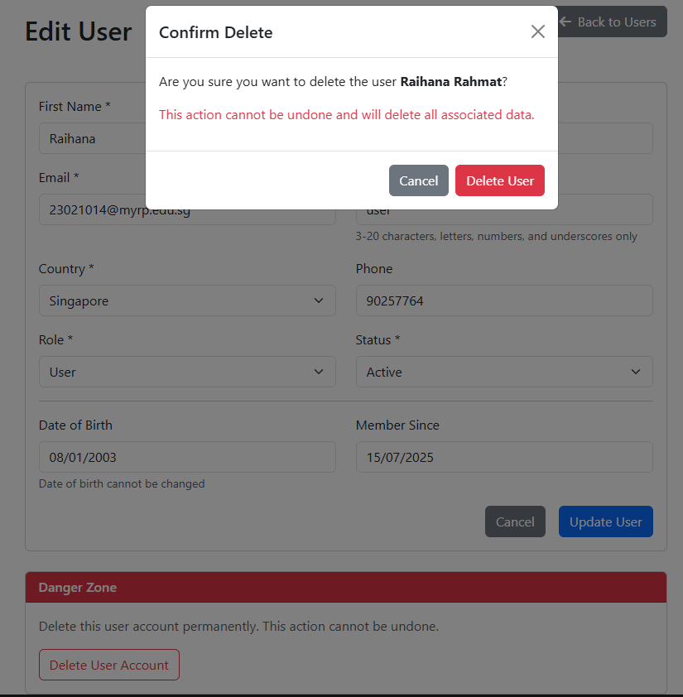
- Soft Delete via Active/Inactive Flag
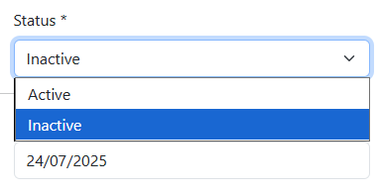
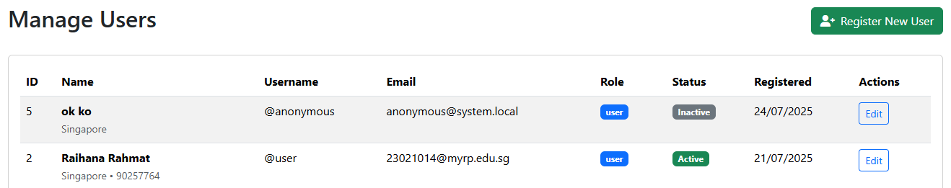
- Click “Register user” to register new user under role admin or user
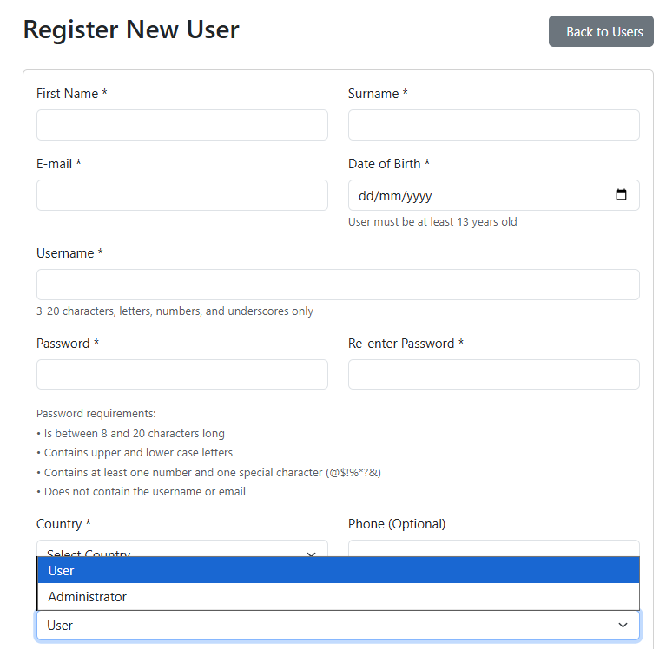

Validations Included:
- Age check (must be 13+)
- Unique email and username
- Password complexity enforced
- Cannot register if invalid

3. Manage Membership Tiers

3.1 Create / Edit Tiers
- Click “Membership tiers”
- Add new tiers: name, price, cashback %, discount %
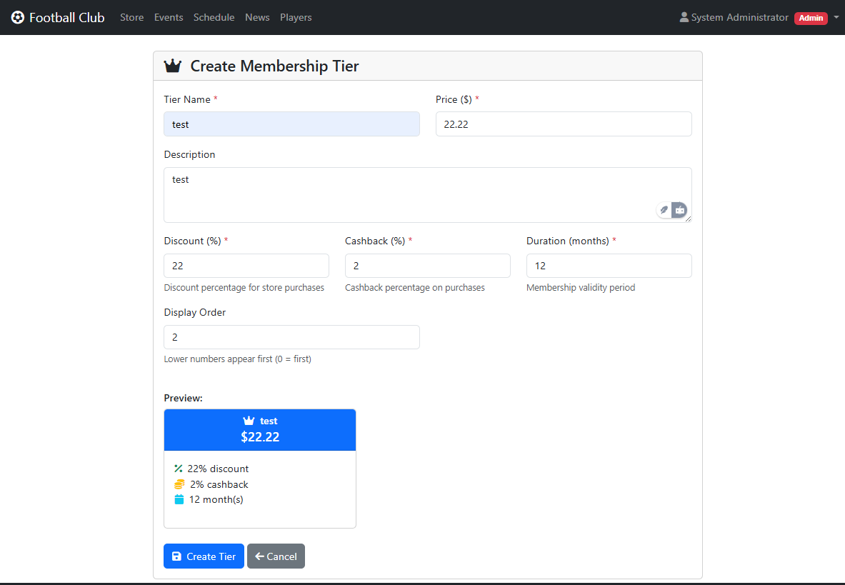
- Edit or delete tiers (that do not have any active memeberships)
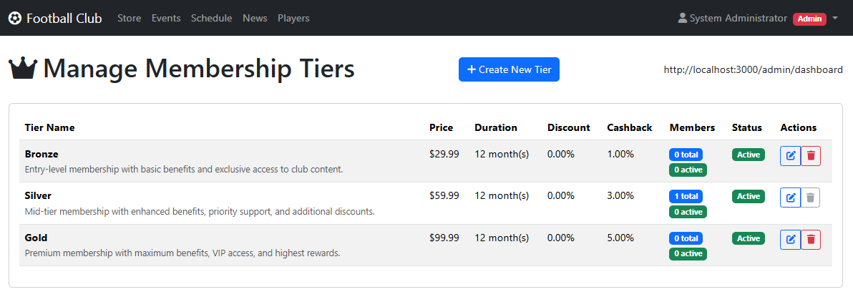

3.2 Manage User Membership
- Click “Manage Membership”
- View list of users and their membership status
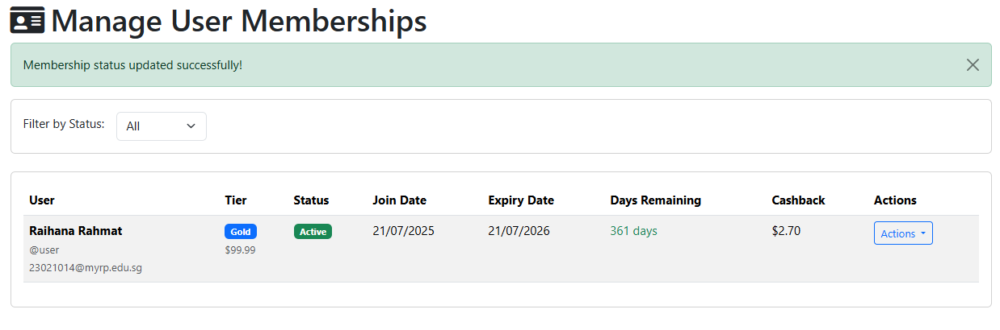
- Manually update status if needed (e.g. expired → renewed)
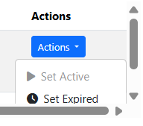
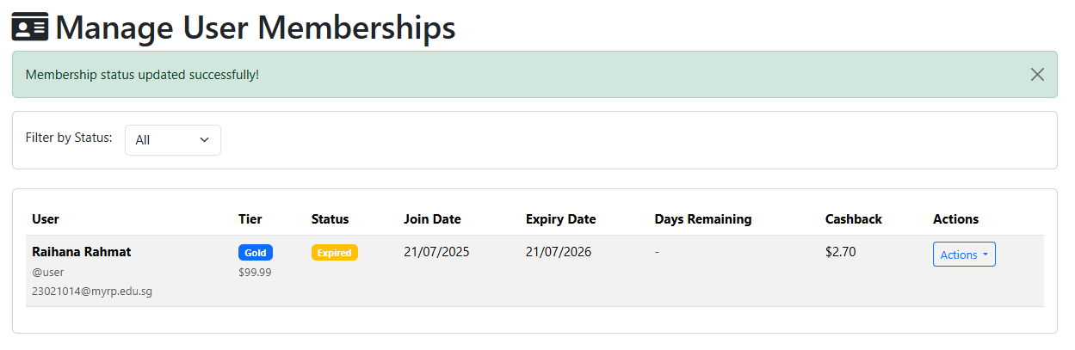

4. Manage Events & Tickets
- Click “Manage Events”
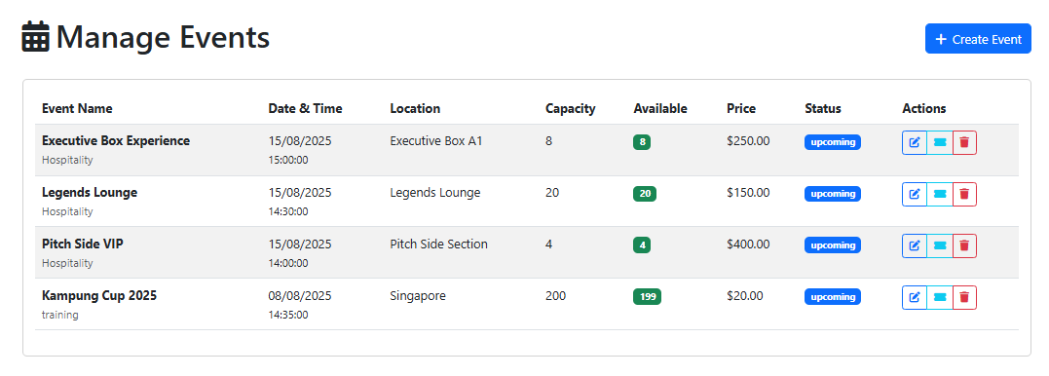

Create / Edit / Delete Events
- Add event details: name, date, time, location, ticket capacity & price
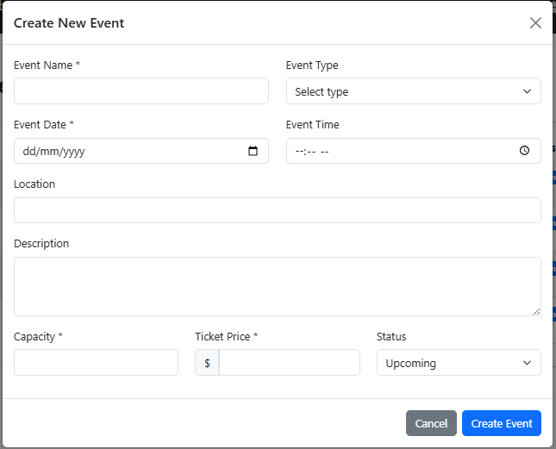
- Update info or remove events

Manage Ticket Purchases
- View who booked tickets for the event (confirmed/cancelled)
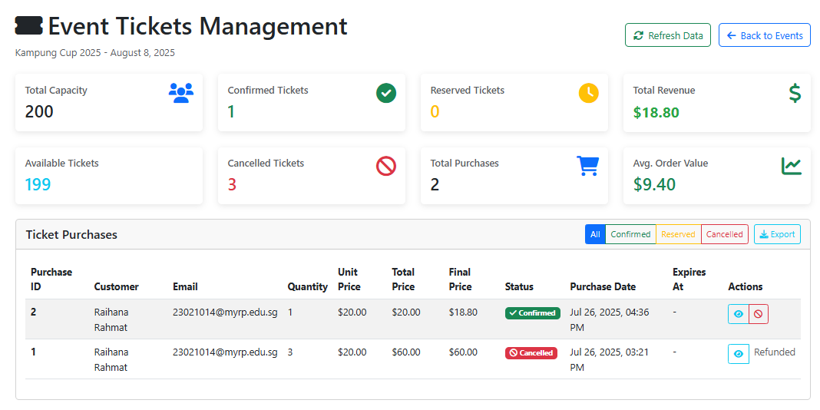
- See ticket detail
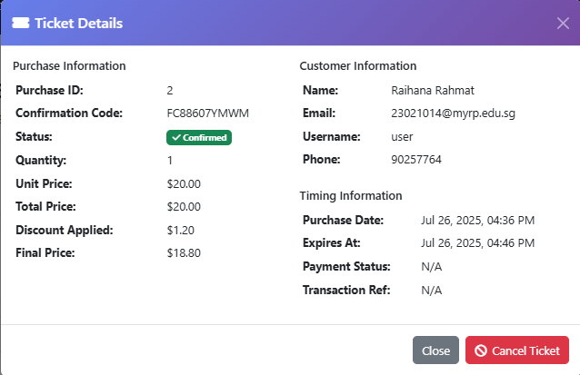
- Process refund requests manually (click → mark as refunded)
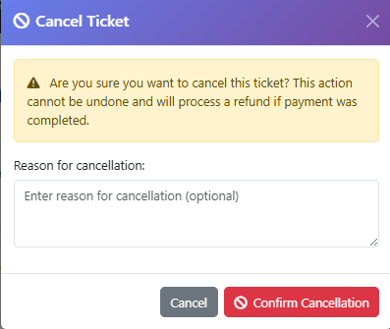
- Download data in CSV format
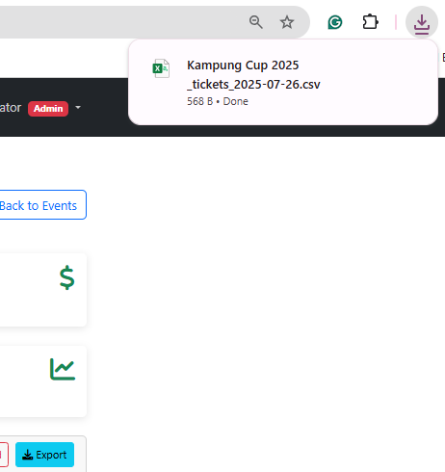

5. Manage News Articles

5.1 News Panel
- Click “Manage News”
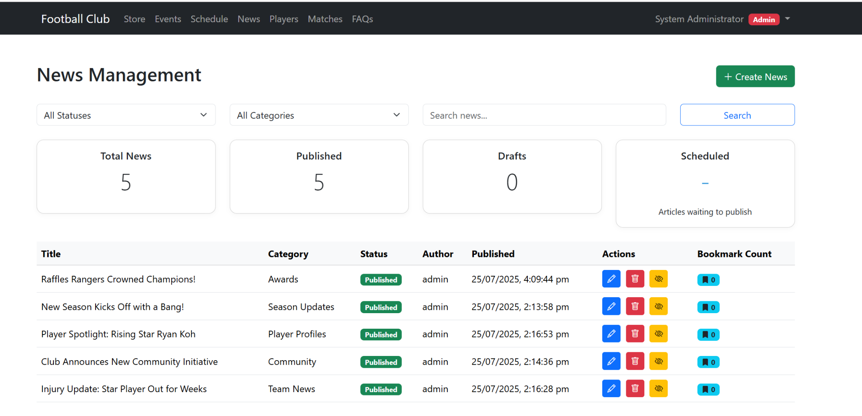
- Add new articles with title, summary, content (links, video, images), headline image & category

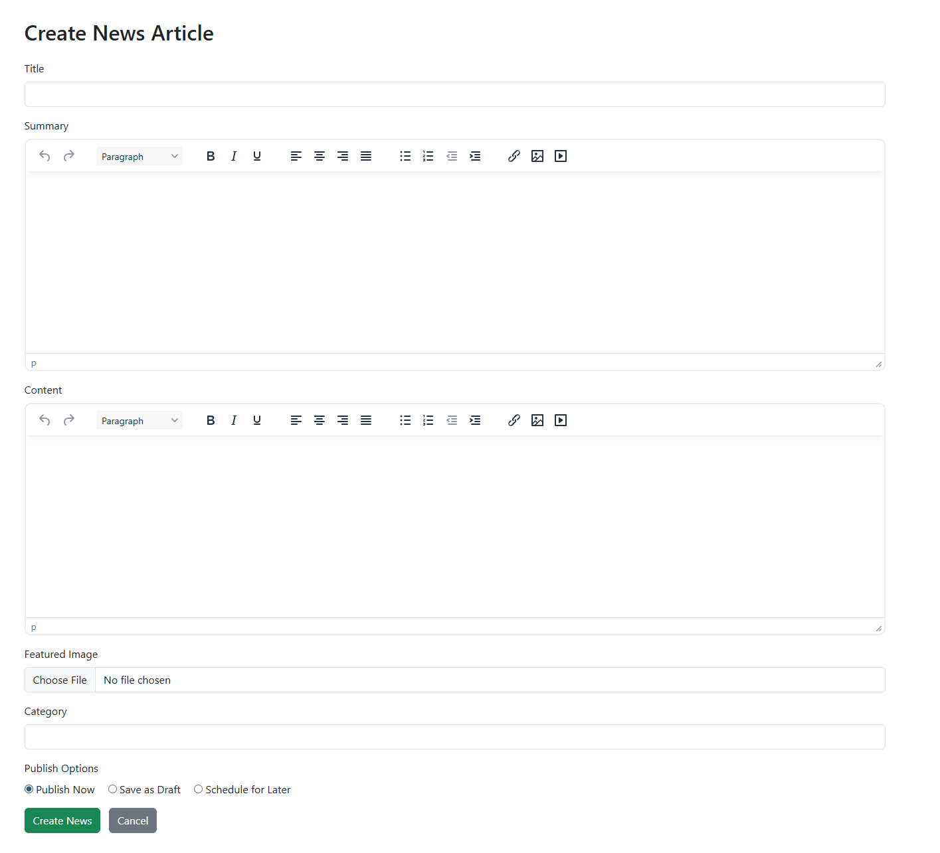

- ‘Autopublish’ function allows admin to schedule future publication of news article (node-cron)

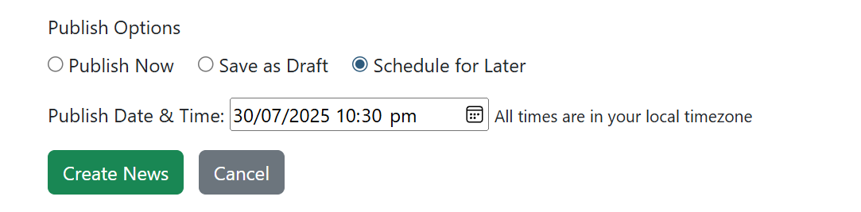

- Edit, delete or publish news (news action buttons)
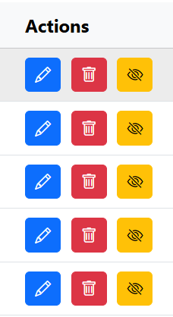

- Logged-in users can bookmark articles → Admin can view how many times an article was saved

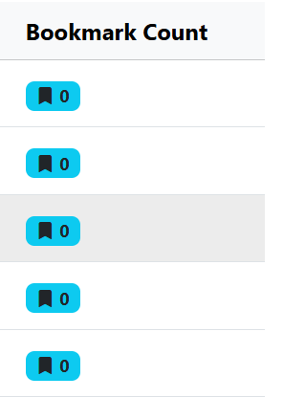

- Publish or scheduled articles to news page
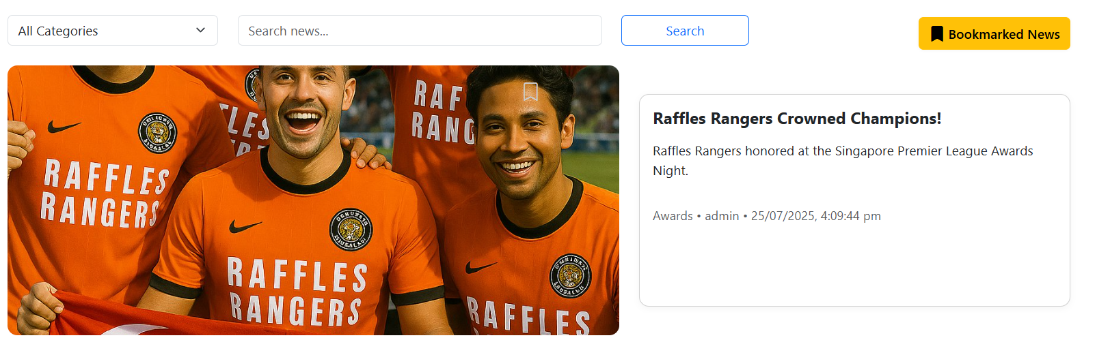

6. Manage FAQs

Review Submitted Questions
- Click “Manage FAQs”
- View pending questions from users
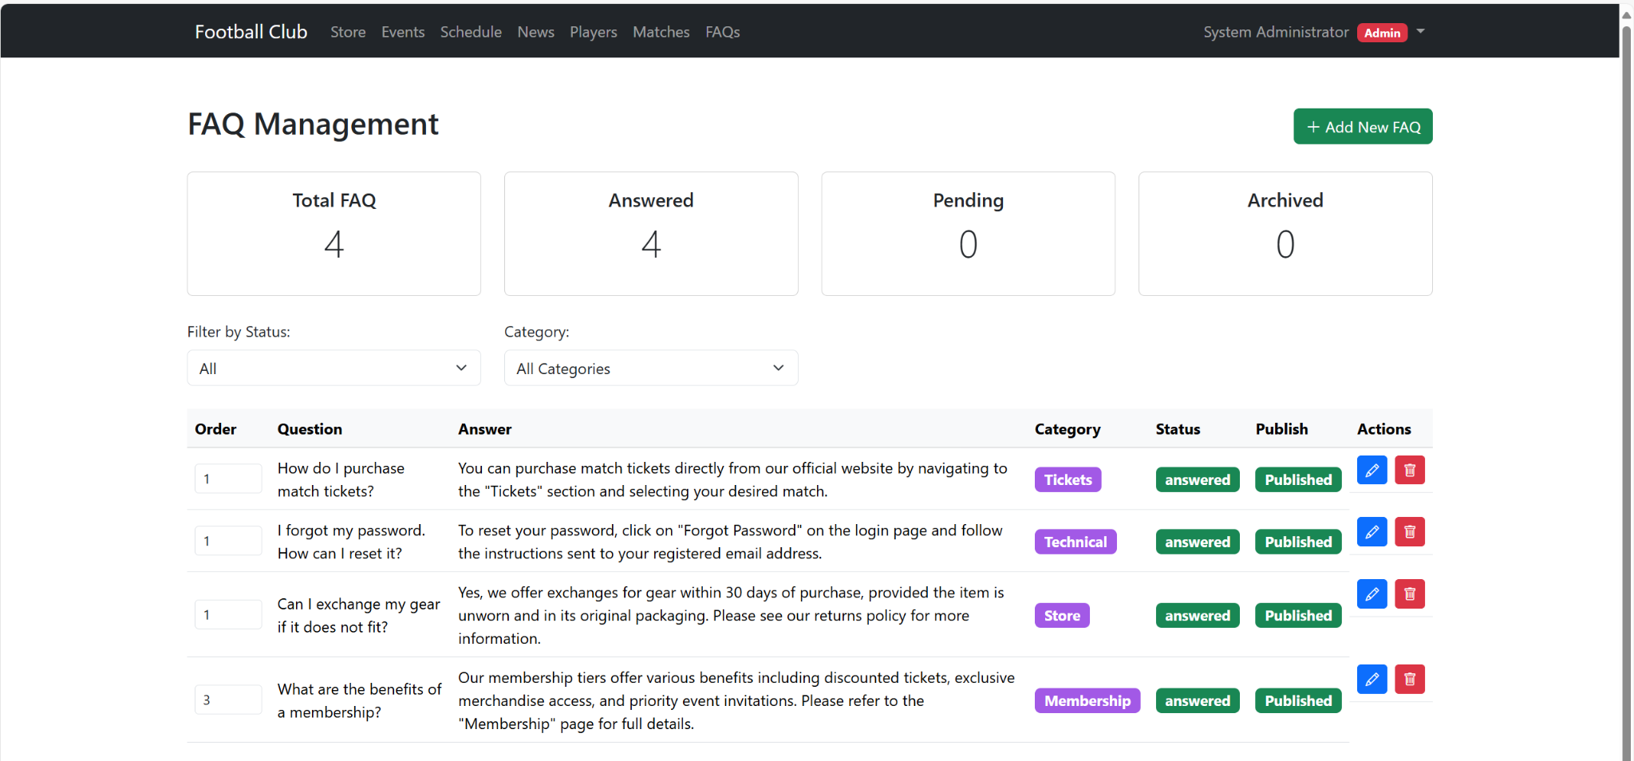
- Add answers, categorise, & set status/order of FAQ to display on UI page
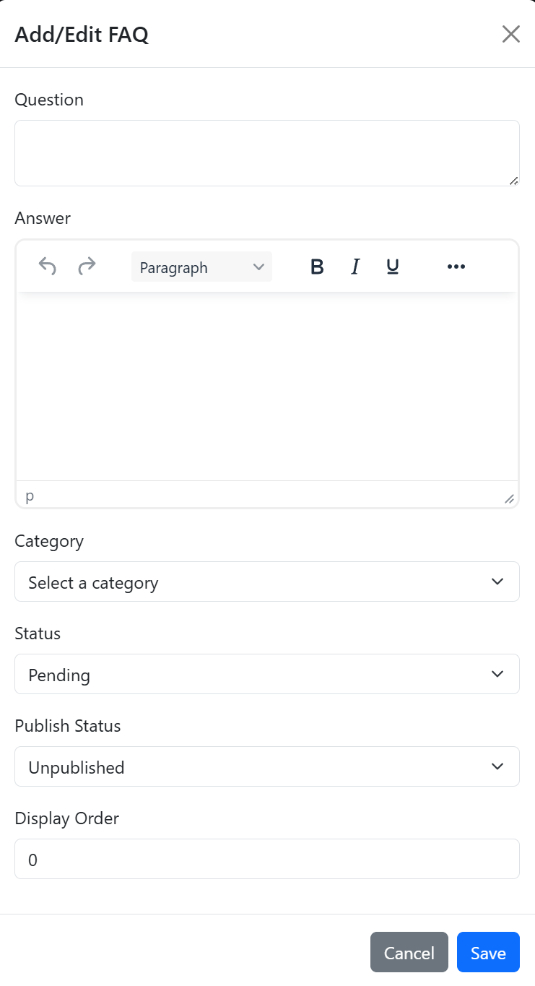
- Edit or delete questions (FAQ action button)
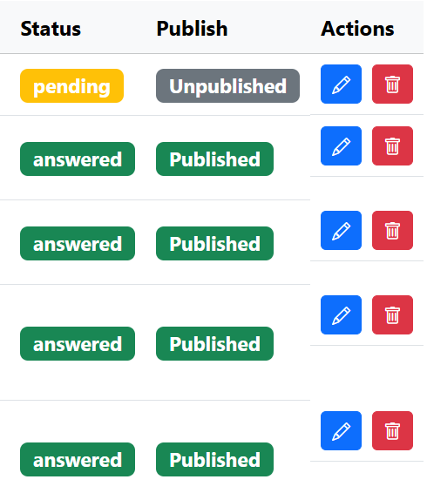
- FAQ will only be published when status is set to both “answered” & “published”

- Publish FAQs
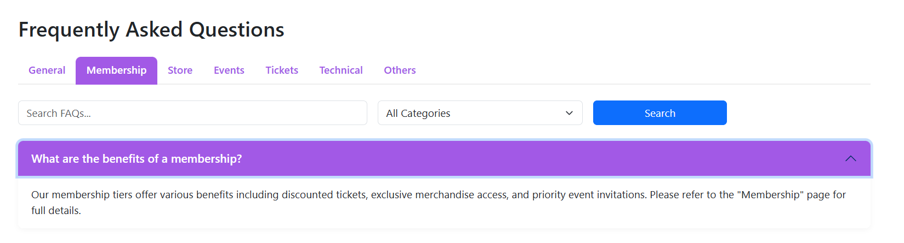

7. Manage Matches

Review Submitted Questions
- Click “Manage Matches”
- View the list of matches
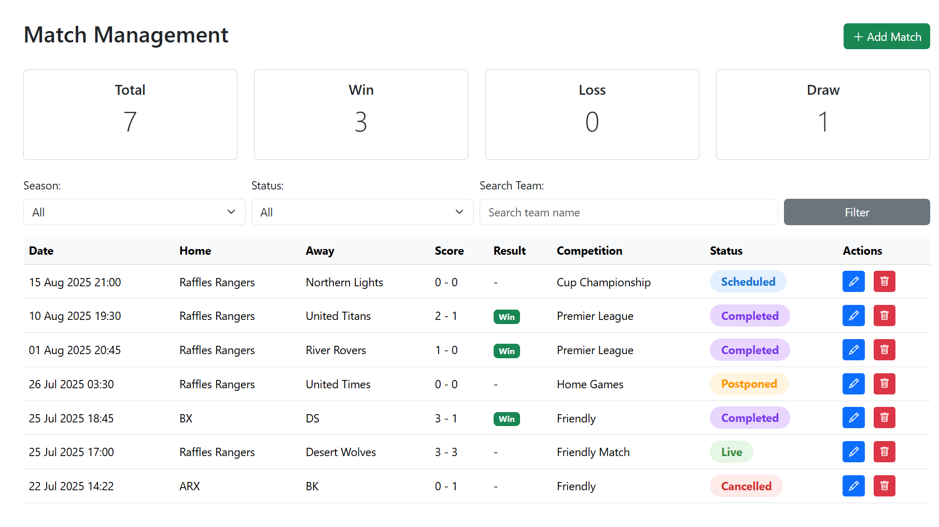
- Match results (win/loss) will be automatically updated only when the match status is set to “completed”
- Add match records (home/away team, match date/time, venue, season, competition, match notes)
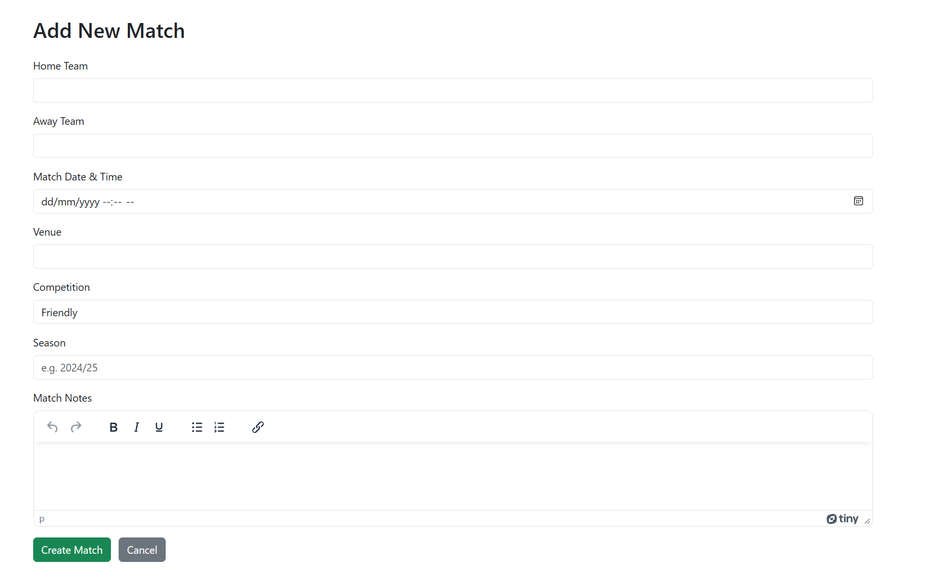

- Edit match records (home/away, match date/time, venue, competition, season, scores, status, match notes)
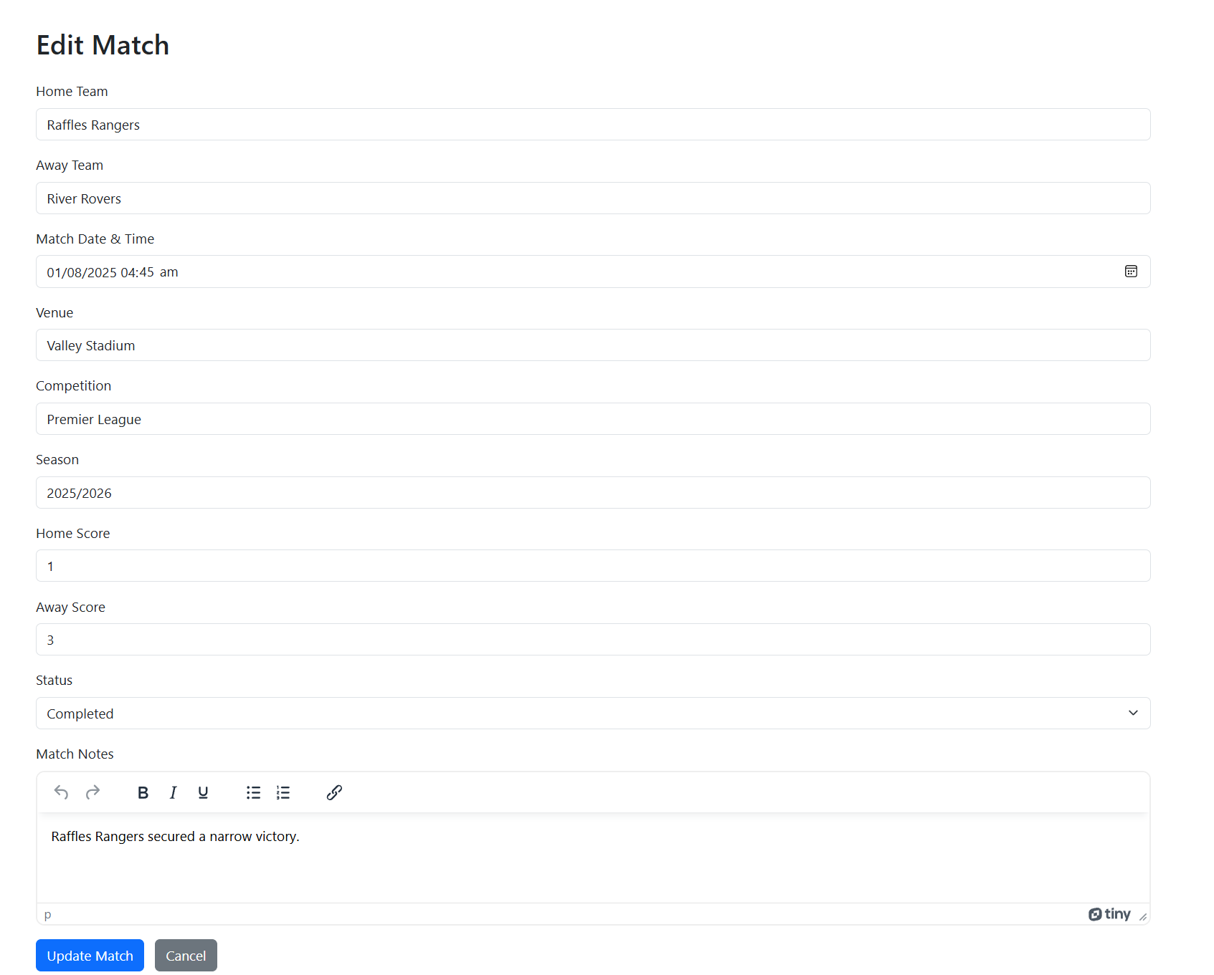
- Publish to the matches page
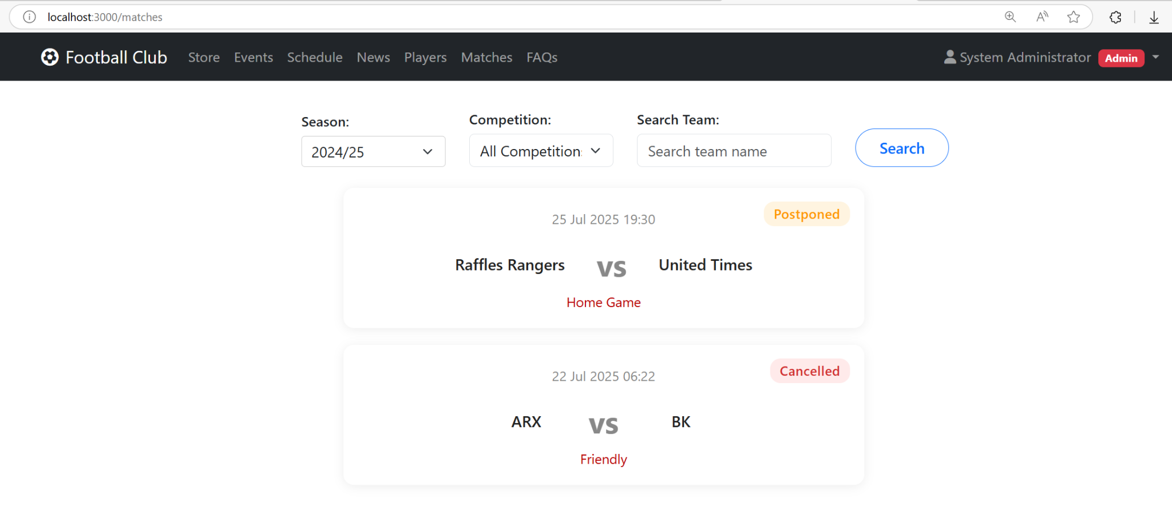
- Admin will be able to view matches with “postponed” or “cancelled” status in matches page

8. Manage Gear / Store Inventory

Gear Management
- Click “Manage Gear”
- Add gear item: name, image, sizes, quantity, price
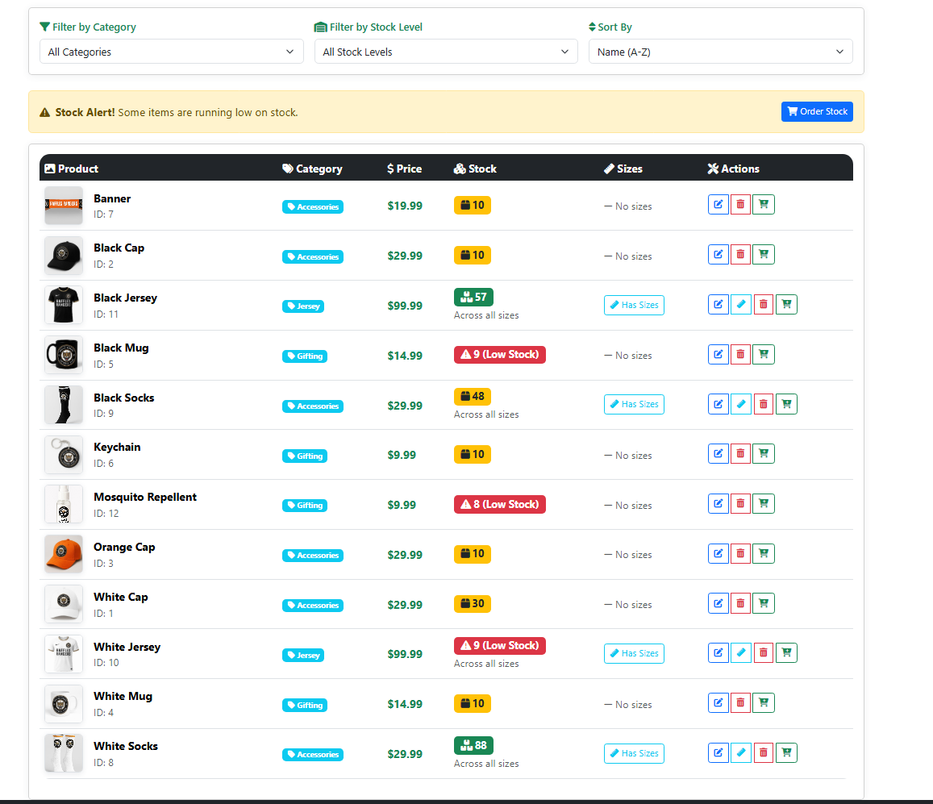

Can also add for sizes
- Edit stock levels or remove item if out of stock
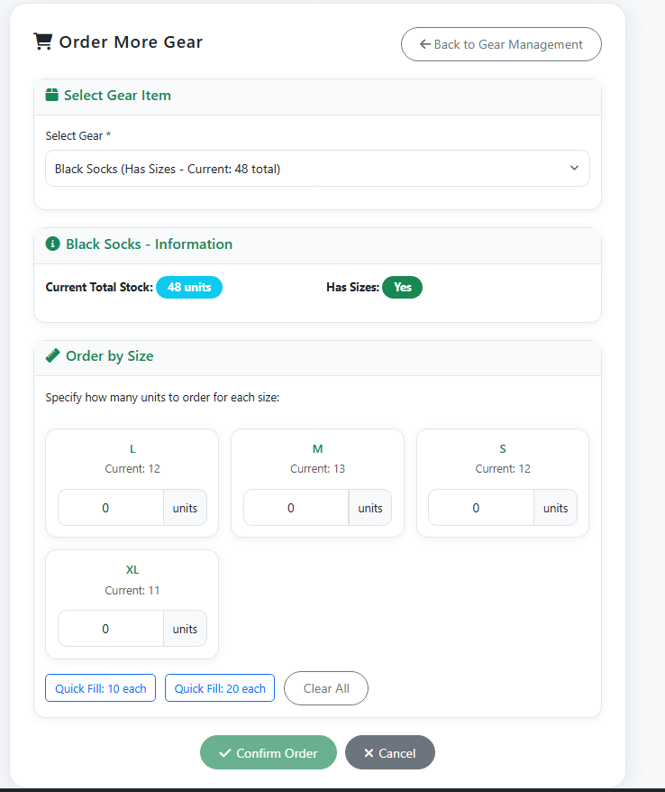
- Stock is auto-reduced after each successful purchase

9. Monitor Payments

View Payment History
- Click “Manage History”
- See all payments by user, date, and item
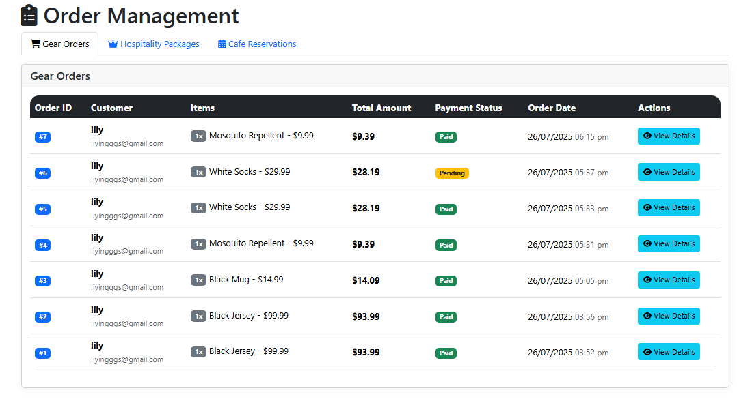
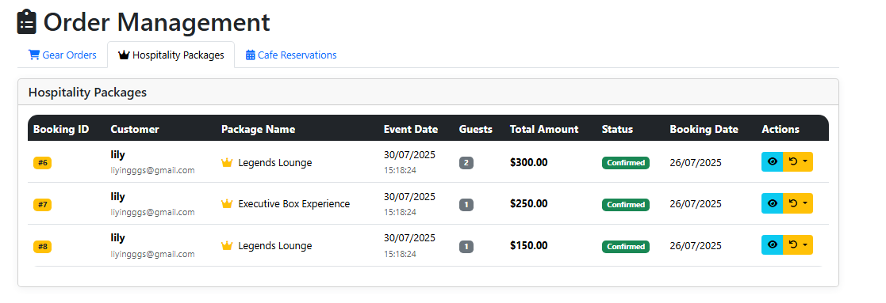
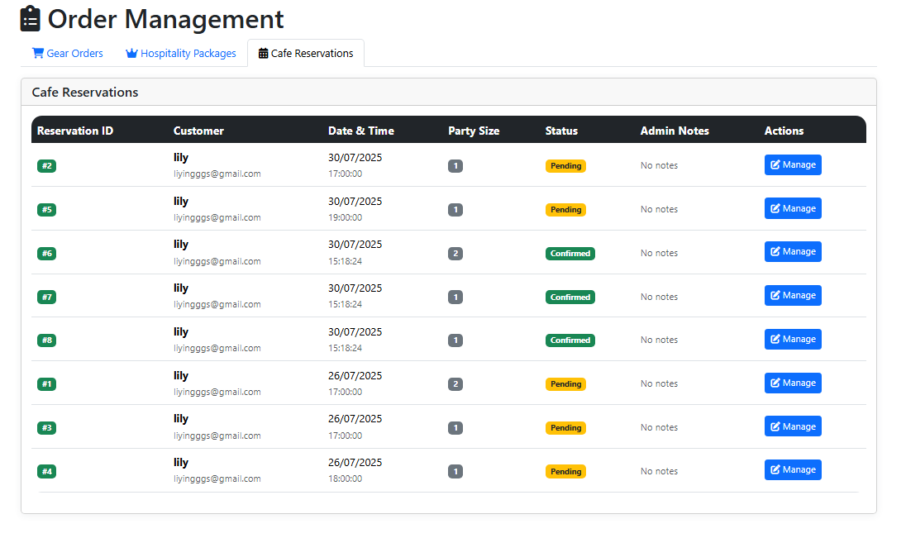
- Filter by status (success, failed, refunded)
- Update payment method if needed

10. Handle Refund Requests
- Click “Manage Refund Requests”
- Access "Refunds" tab
- View request form submitted by user
- Click “Approve” → Refund processed (manual entry)
- Click “Reject” → User notified with reason
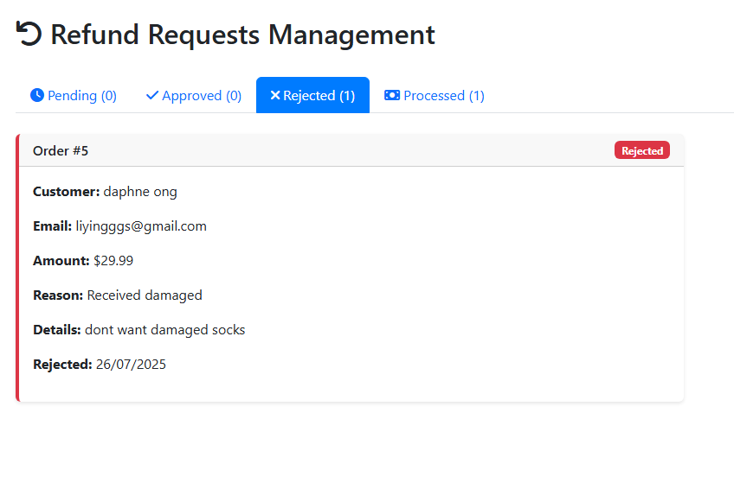
- Processed once refunded back
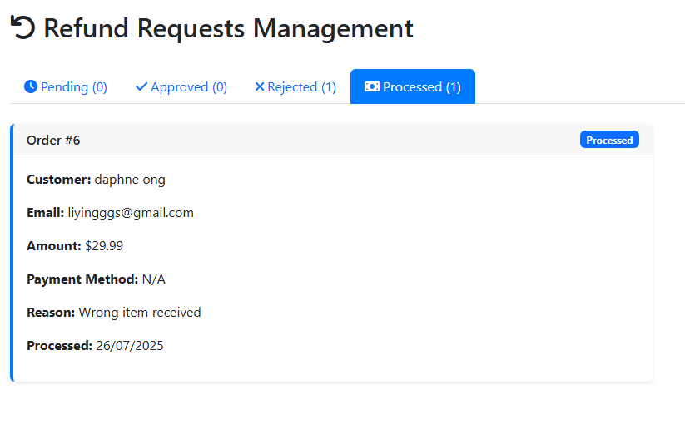

11. Manage Players
- Click “Manage Player”
- Overview of active/injured players (Edit/Hide)
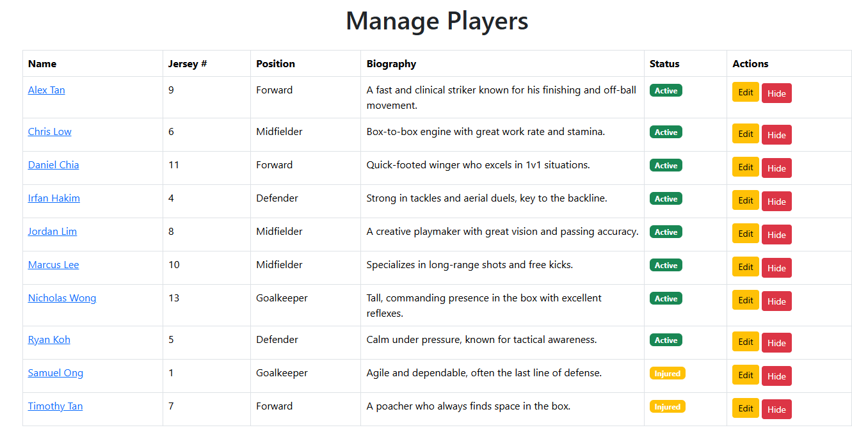
- Hidden players table (Delete/Restore)
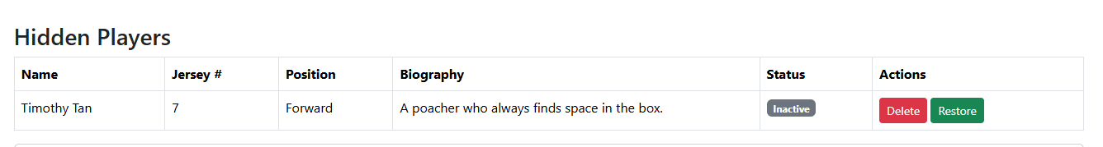
- Add new player
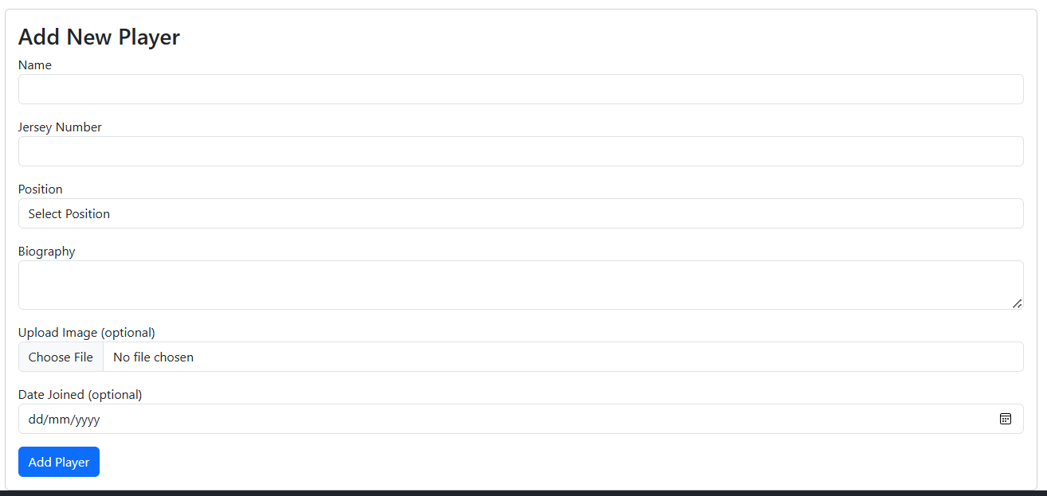
- Edit player
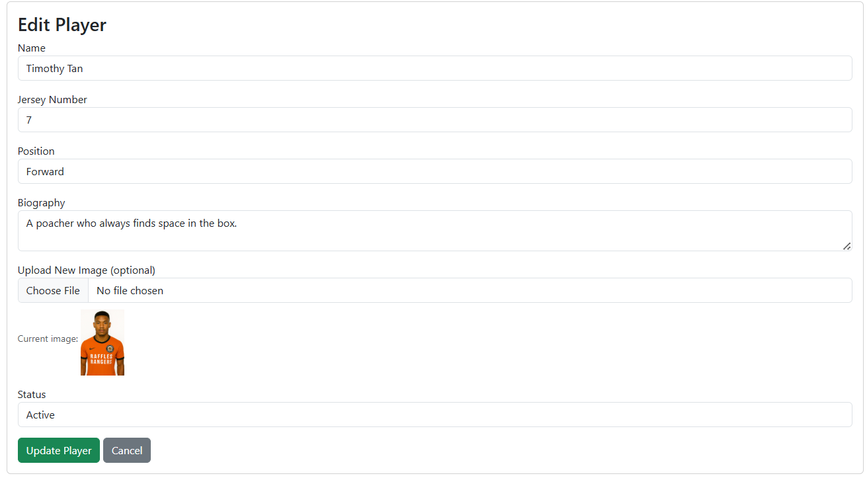

12. Manage Schedule
- Click “Manage Schedules”

Add new schedule
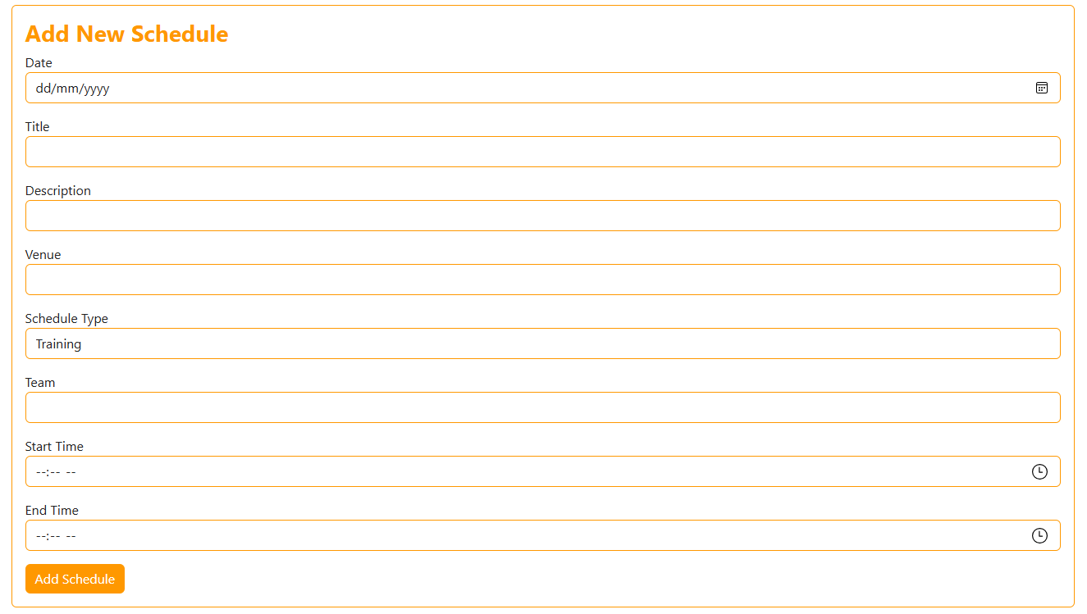

Edit/Delete schedule
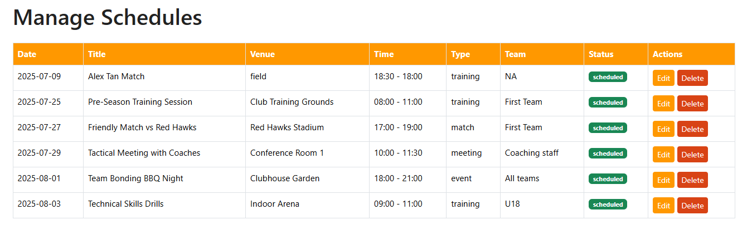

Approve/Decline pending bookings from user

